Question 3 Notes

Question 3 A
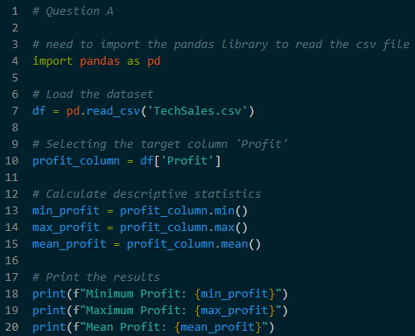
- Generating basic statistics for the Profit column to understand the overall performance
- Load Data – Use the pandas library to read the CSV file into a data frame
- Select Column – Target the Profit column for calculation
- Calculate Statistics
  - Minimum – Find the lowest profit value using .min()
  - Maximum – Find the highest profit value using .max()
  - Mean – Find the average profit using .mean()

Question 3 B
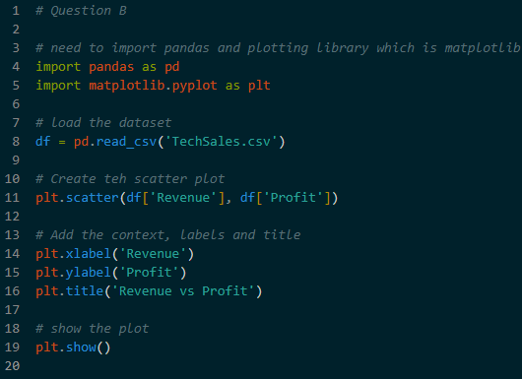
- Importing maplotlib.pyplot as plt to create a charts
- Creating a visual representation of the Revenue vs Profit
- Using plt.scatter to create a scatter plot visualization
- Format chart – Add necessary labels such as title, X-axis, and Y-axis to make the data easy to read

Question 3 C
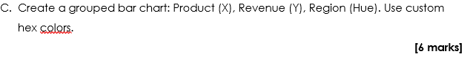
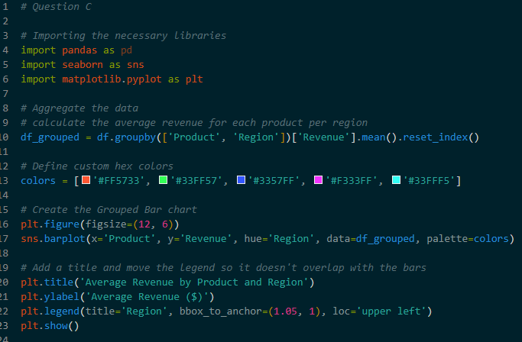
- Prepare Data – Calculate the total revenue for every region in the dataset
- Creating plot – by using a visualization library like matplotlib to generate a chart
  - Sns.barplot – for plotting barchart
- Format Chart – Add necessary labels such as title, X-axis and Y-axis to make the data easy to read

